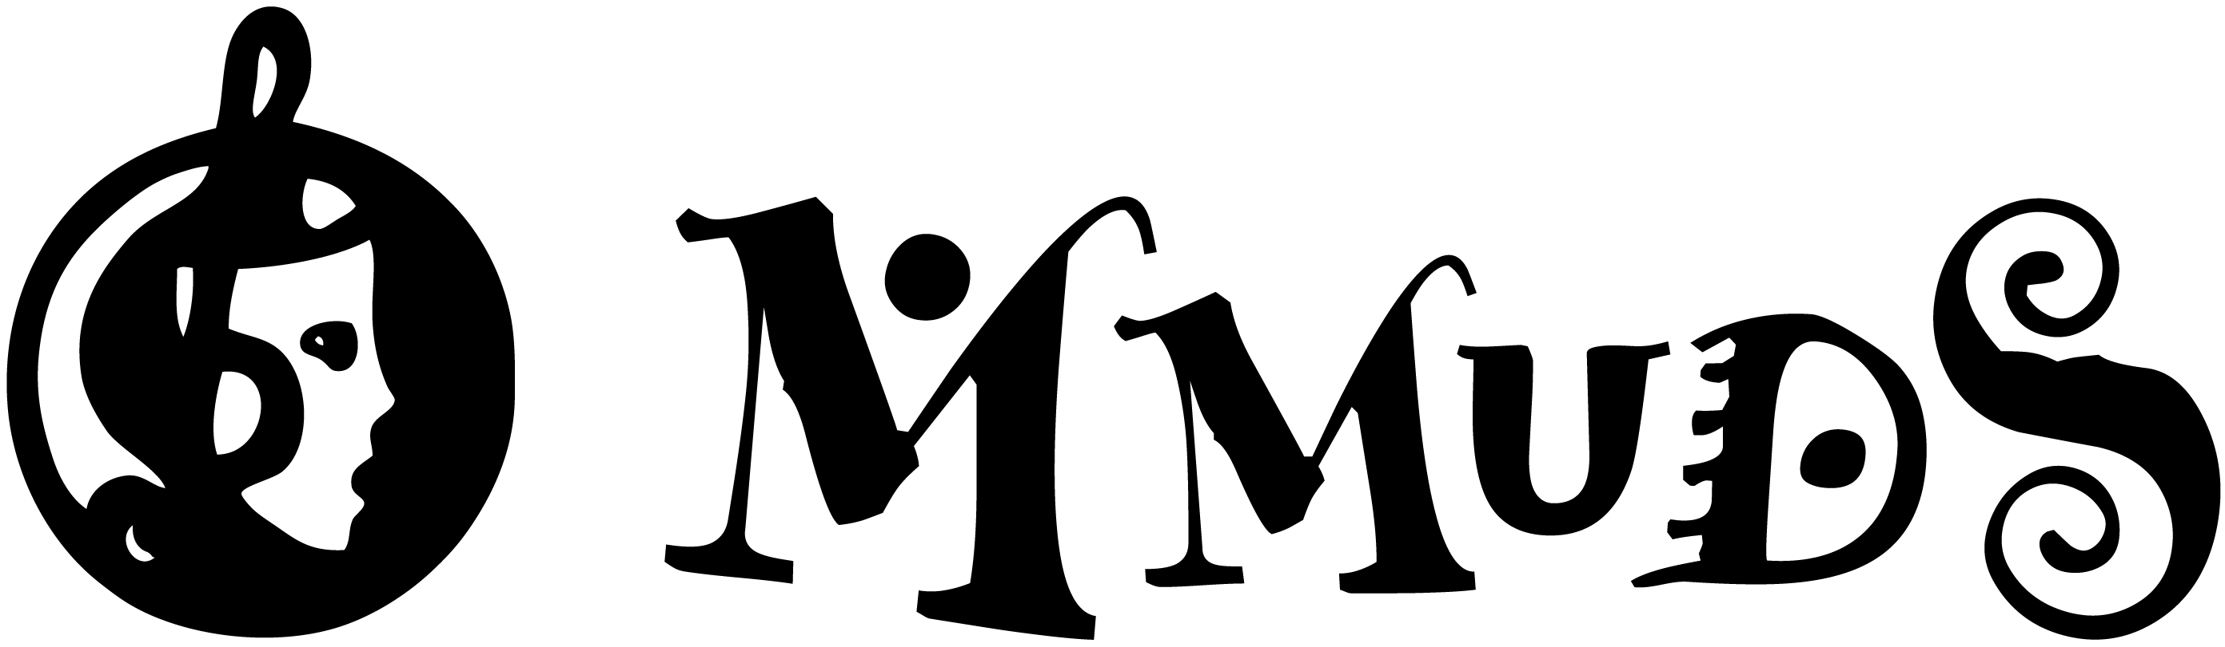

Show Proposal Application Form

Overview for those wanting to stage a show with MMuDS

MMuDS aims to present a minimum of 2 of shows each year. Shows may include, but are not limited to, musicals, reviews and plays. You are requested to read the following and provide the requested information to assist the Committee in determining the outcome of your application. Currently shows are being considered up to 2 years prior to performance.

MMuDS will explore a range of show options. Shows need not fit any particular style. It could well be a new work or a show that is less well known. The MMuDS committee will consider, among other factors, the proposed show’s general audience appeal, its appeal to specific community sectors and its capacity to recover the total cost of production.

MMuDS has a long history of presenting quality productions and expectations are ever increasing. To ensure continuing high standards, the Committee will only consider proposals that demonstrate a thorough understanding of the show’s artistic and technical requirements. The proposal must also confirm the appointment, subject to Committee agreement, of director, producer and musical director (if relevant), with appropriate levels of experience.

A detailed budget must also be presented with all show proposals.

The MMuDS Committee is responsible for the overall financial management of the Society. The Committee will approve a budget for a proposed show and monitor the actual financial outcomes against the budget. The routine management of the show budget is however the responsibility of the director and production team. Any variations to the budget may only be made with the approval of the Committee.

The Director and Producer must attend MMuDS Committee meetings, as required by the Committee, in the months preceding, during and post production.

MMuDS encourages the participation of new people in its productions. We will ensure that inexperienced participants will be given training and the opportunity to work with experienced members. Novice directors and producers must have significant experience before they will be given full production responsibility. Internships & mentoring to provide experience in key production roles, ie director, stage manager, producer, will be offered to ensure successful and enjoyable production outcomes.

The Committee would recommend to any new director to MMuDS that in filling out the ‘Show Proposal Application Form’, they should contact the MMuDS Secretary who will help with this part of the process.

Good luck and if you have any questions please contact the secretary at secretary@mmuds.org.au

Show Proposal Application Form

- Show title & synopsis, character breakdown, chorus parts etc? (Usually found on the website of the licensing company)
- Is License available? Who is the license Company?
- Please indicate proposed rehearsal & show dates?
- Director role: MMuDS enjoys welcoming 'first time' directors. It is however essential for them to have been in either a co/assistant director or stage manager role previously. If a person wishes to be a director there are many opportunities to work on other shows to develop the skills required to direct their own.

Directors have overall responsibility for the management of all rehearsal, technical and performance requirements. They must have good communication skills and the ability to effectively manage their production team and cast members. They should also have a good understanding of the MMuDS organisation. It is the director’s job to recruit for the key production roles. ie producer, co/asst. director, stage manager, makeup manager, choreographer, sound manager, effects designer, lighting manager, graphics designer etc. The director has overall artistic discretion for the show.

Who is your proposed director and what is their experience?
- Co-Director & Assistant Director. Your proposed co-director or assistant director should have previous direction/production experience with MMuDS or another theatre company/group.

Who is your proposed co-director or assistant director and what is their experience?
- Your musical director should have experience either in MMuDS shows or other areas of music involving ensemble leadership?
Who is your proposed musical director and what is their experience?

- Producer role: The producer should have had experience in a senior production role. The producer manages production meetings and must ensure that all areas of the production are running to schedule and budget. The producer will be required to provide regular reports to the Committee on the progress of the show.

Who is your proposed producer and what is their experience?
- Distribution of director/co-director/producer responsibilities will vary according to show requirements and the specific skills of the personnel. Please provide a general outline of the responsibilities for these key roles.
- Are the director/s, producer & musical director prepared to commit fully to the rehearsal & show schedule?
- Indicate any other key personnel to be part of production team. What skills do they bring to the project?
- Are there any outstanding production resources or issues not covered by this application?

- Are there any specialist areas that are required for this show? eg. special effects designer/choreographer/film maker etc?
- The director, co/assistant director and producer must be available to attend MMuDS monthly Committee meetings, as required, in the months preceding, during and post production. The Committee will provide for this as the first item of business and it will be dealt with as quickly as possible. Will your team commit to this?
Failure to meet this requirement may result in the show being cancelled.
- Budget. A draft budget, to accompany this application, should be prepared in consultation with the MMuDS Treasurer using the template provided.
- Have you made a preliminary enquiry to ensure the preferred venue is available for rehearsals & performances?
- Outline the orchestral/band requirements for the show.
- How will auditions and cast selection occur?

- Have you read and agree to MMuDS Audition Policy found on the website
http://www.mmuds.org.au/MMuDS-Audition_Casting-Policy
- What is the director’s vision for the show?
- Please provide any reviews or other information that may assist the Committee in its decision?

- MMuDS is a Safe Child organisation. Shows that involve children and young people require that personnel who are likely to come into contact with children or young people ie Stage Manager & crew, Makeup Manager, Directors, Choreographers, adult cast members etc. must have a current Working With Children Certificate. For volunteers there is no charge for the certificate.

Do all of your key personnel have a Working With Children Certificate or are they willing to apply for one?
If you have any questions relating to these requirements please contact the MMuDS Committee at secretary@mmuds.org.au
- MMuDS Child Safe Code of Conduct & Statement of Commitment to Child Safety.
Do you agree to these rules found on the MMuDS website? http://www.mmuds.org.au/values
The Director & Producer are required to familiarise themselves with MMuDS OH&S Policy and Procedures and comply with their requirements. In the case of the need for any clarification the Director and/or Producer must contact the MMuDS President. Do you agree to this?
- I agree to conform to the MMuDS Rules of Association, policies, guidelines, protocols and all other requirements set out in this Application.

The MMuDS Committee will consider your request in principle and, if the application is supported, you will be asked to meet with the Committee to elaborate on your proposal. The MMuDS Committee will make every effort to advise you of the outcome of any discussions as soon as possible following your application.

Name: Sign: Date:

